**What are three conclusions we can make about Kickstarter campaigns given the provided data?**

* Project launched in theater, music and film & video program tend to have higher rates of successful over all the projects, and **Music program tend to has the lowest rate of fail among these 3 categories**
* Plays, Rock and Documentary tend to have the highest rate of successful among all sub-category, where **Rock and Documentary have no history of failed up to date**
* Based on the historical trend, projects launch in Feb to May tend to be successes and it usually starts to decline since June; December seemed not to be a month to launch campaigns where tend to has the lowest successful rate

**What are some of the limitations of this dataset?**

As Kickstarter is an American company and 74% of the project was launched in US, creator and backer from outside of states has very limited historical data to analyze if it will be successes to launched certain project outside of states or even with non-English based environment or not

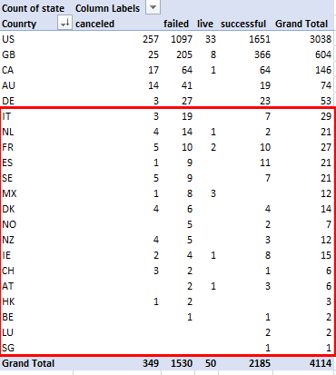

**What are some other possible tables/graphs that we could create?**

* To understand the duration of each projects, we can create a project duration column, and compare them along with the results

Duration (Day): Date Ended – Date Created

* Project tend to be failed or canceled once it last 35 days or longer

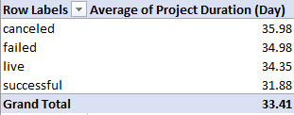

* We may also create a project counts and result counts by country pie chart to understand the proportion of project counts in each country

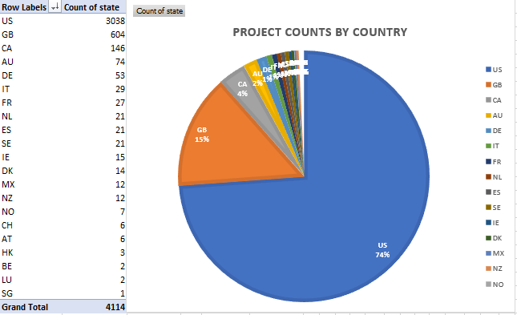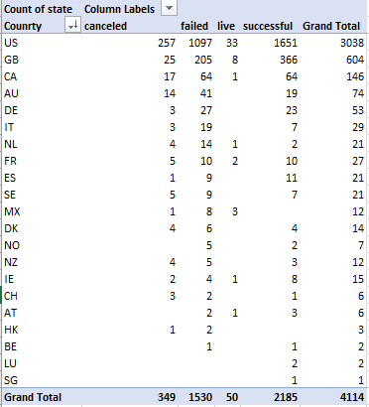

* The average percent funded per sub-category table/chart can be created to view the percent funded horizontally over all the projects along with their results and understand the what are the sub-cats that tend to reaches their goals from backer’s perspective

